**Software Engineering Department  
ORT Braude College**

**Capstone Project Phase A – 61998**

**PulseVision: Video Based Heart Rate Measurement Using Variable Lighting**  
25-1-D-4

Nadav Reubens | [nadav.reubens@e.braude.ac.il](mailto:nadav.reubens@e.braude.ac.il)

Ron Sisso | [ron.sisso@e.braude.ac.il](mailto:ron.sisso@e.braude.ac.il)

Supervisors:

Dr. Dan Lemberg | [lembergdan@braude.ac.il](mailto:lembergdan@braude.ac.il)

Mrs. Elena Kramer | [elenak@braude.ac.il](mailto:elenak@braude.ac.il)

**Git repository link:**

[**PulseVision**](https://github.com/RonSisso/PulseVision)

Table of Contents

Abstract 3

1 Introduction 3

2 Background and related work 5

2.1 Medical background – Cardiovascular system 5

2.2 Photoplethysmography (PPG) and Remote PPG (RPPG) 6

2.3 Impact of Lighting Conditions on PPG Signals 7

2.4 Signal processing techniques 11

2.5 Image processing techniques 14

3 Expected achievements 15

3.1 Outcome 15

3.2 Criteria for success 15

3.3 Special Components and Engineering/Research Challenges 17

4 Research / Engineering process 18

4.1 Process 18

4.2 Product 22

5 Evaluation / Verification plan 43

5.1 Evaluation Strategy 44

5.2 Verification Plan 45

5.3 Test Plan 46

References 50

Image References 51

# Abstract

Heart rate measurement is a fundamental parameter for assessing a patient’s health and is widely used in medical diagnostics, sports performance analysis, and remote healthcare applications. Non-contact heart rate monitoring offers significant advantages by eliminating the need for physical sensors, thereby enhancing patient comfort and reducing the risk of contamination. Previous studies have successfully utilized video-based techniques to measure heart rate under continuous lighting conditions. However, artificial lighting sources such as LEDs and fluorescent lights introduce periodic flickering due to their non-continuous nature, which can interfere with accurate heart rate extraction.

This project extends prior research by addressing the challenges posed by non-continuous lighting conditions in video-based heart rate measurement. The proposed system leverages the green light channel, which has been shown to provide optimal signal clarity in physiological imaging, and incorporates advanced image processing techniques to mitigate the effects of flickering. The project includes a detailed analysis of wave propagation and the impact of lighting-induced distortions on heart rate signals. Additionally, signal processing enhancements, including adaptive filtering and frequency domain analysis, will be implemented to improve measurement robustness. By refining non-contact heart rate detection under challenging illumination conditions, this research aims to contribute to the broader field of remote health monitoring and biomedical imaging.

**Keywords:** Heart rate measurement, Non-contact monitoring, Video-based analysis, Green light channel, Non-continuous lighting, Signal processing, Frequency domain analysis.

## Introduction

In the modern era, advancements in healthcare technology have significantly improved patient monitoring and diagnostics. Non-contact heart rate measurement has emerged as a promising alternative to traditional contact-based methods, offering enhanced patient comfort and usability in various healthcare and fitness applications. This technology is particularly valuable in environments where continuous monitoring is required, such as hospitals, remote healthcare facilities, and sports science laboratories. However, the accuracy and reliability of non-contact methods remain a challenge, especially under varying lighting conditions.

Traditional heart rate monitoring methods, such as pulse oximeters and electrocardiograms (ECGs), require direct physical contact with the patient. While these methods provide accurate readings, they can be intrusive, uncomfortable, and impractical for continuous, long-term monitoring. In contrast, video-based heart rate measurement leverages image processing techniques to extract cardiovascular signals without physical sensors. This approach utilizes subtle color variations in the skin, particularly in the green light channel, to detect pulsatile blood flow and estimate heart rate.

Building upon previous research, this project aims to extend the capabilities of non-contact heart rate measurement by addressing the challenges posed by non-continuous lighting conditions. A prior study successfully demonstrated heart rate extraction using video processing under natural and continuous artificial lighting. However, the presence of flickering in non-continuous light sources, such as LEDs and fluorescent lamps, introduced significant signal distortions, reducing measurement accuracy.

To overcome these limitations, this project focuses on developing a robust signal processing framework that compensates for the effects of flickering light. The system will analyze the wave properties of the light source and their interaction with physiological signals, implementing advanced filtering and frequency-domain techniques to enhance signal clarity. By improving the stability of heart rate measurements under varying lighting environments, this research aims to contribute to the broader field of biomedical imaging and remote health monitoring.

The following sections of this paper will provide a comprehensive overview of related work in non-contact physiological measurement, present the theoretical background on light-wave interactions and signal extraction, and describe the proposed system architecture. Furthermore, the research methodology, data processing techniques, and evaluation framework will be outlined. Finally, the study will discuss the anticipated impact of this research on real-world healthcare applications and future improvements in video-based biometric monitoring.

## Background and related work

Non-contact heart rate measurement has gained considerable attention in recent years due to its potential to provide non-invasive, real-time monitoring of vital signs across a range of applications in healthcare, sports science, and remote patient monitoring. Accurate and timely heart rate measurement is essential in diagnosing and managing cardiovascular conditions, particularly in medical environments. Traditional methods, such as pulse oximeters and electrocardiograms (ECGs), require direct physical contact with the patient, which can be uncomfortable, especially for elderly individuals or long-term monitoring. In contrast, non-contact methods offer an alternative by leveraging photoplethysmographic techniques using video data to estimate heart rate without requiring sensors attached to the skin.

The primary mechanism underlying this approach is **photoplethysmography (PPG),** which measures blood volume changes by analyzing variations in light absorption. The remote variation of this technique, known as **Remote Photoplethysmography (RPPG)**, uses cameras instead of direct light sensors to capture changes in skin reflectance that occur with each heartbeat. Among the three primary color channels (red, green, and blue), the **green channel** is preferred due to its sensitivity to hemoglobin absorption, providing a strong signal-to-noise ratio for detecting cardiovascular activity.

While significant progress has been made in video-based heart rate monitoring, several challenges remain, particularly when ambient lighting conditions vary. **Non-continuous lighting sources, such as LED and fluorescent lights, produce periodic flickering due to alternating current (AC) power supplies. This flickering introduces noise that can interfere with accurate signal extraction.** Addressing this challenge is the primary goal of this project.

### Medical background – Cardiovascular system

The cardiovascular system is responsible for transporting oxygenated blood throughout the body, ensuring that tissues receive the necessary nutrients for cellular function. It consists of the **heart, blood vessels, and blood**, which work together in a continuous cycle of oxygenation and circulation. The heart beats rhythmically, contracting (systole) to pump oxygen-rich blood into arteries and relaxing (diastole) to allow blood to return via veins.

**Hemoglobin**, a key component of red blood cells, plays a vital role in oxygen transport. It binds with oxygen in the lungs to form **oxyhemoglobin**, which gives blood its bright red color. This process directly affects skin reflectance properties, making it possible to extract cardiovascular signals using optical methods such as **Photoplethysmography (PPG)**. The forehead, which receives blood primarily from the **internal carotid artery**, is particularly suitable for non-contact heart rate monitoring as it exhibits stable blood flow with minimal motion artifacts.

### Photoplethysmography (PPG) and Remote PPG (RPPG)

#### PPG

Photoplethysmography (PPG) is a non-invasive optical technique that measures changes in blood volume using light absorption. A light source, typically infrared or green light, illuminates the skin, and the reflected light is captured to detect periodic variations caused by the cardiac cycle. The resulting PPG waveform provides insight into heart rate and cardiovascular activity. PPG is commonly used in medical devices such as pulse oximeters, where it is applied at fingertips or earlobes for continuous monitoring.

#### RPPG

Remote Photoplethysmography (RPPG) extends PPG principles to video-based heart rate monitoring. Instead of using direct-contact light sensors, RPPG analyzes subtle color variations in the skin using standard cameras. These variations, particularly in the green channel of the RGB model, correspond to blood volume fluctuations, allowing heart rate to be extracted. Facial regions such as the forehead and cheeks are commonly used as regions of interest (ROI) for signal extraction. However, RPPG is highly sensitive to motion artifacts, skin tone variations, and ambient lighting conditions, requiring robust signal processing techniques for accurate measurement.

### Impact of Lighting Conditions on PPG Signals

Photoplethysmography (PPG) relies on the interaction between **light and biological tissues** to extract cardiovascular signals. However, **ambient lighting conditions,** particularly those involving **non-continuous light sources such as LEDs and fluorescent lights**, can significantly impact the accuracy and stability of PPG signals. Flickering, variations in intensity, and spectral distortions can introduce **undesired artifacts**, making it challenging to extract precise heart rate information.

The figure illustrates the impact of ambient light variations on the PPG signal. The top graph represents the bandpass-filtered PPG signal, showing periodic oscillations corresponding to blood volume changes. The bottom graph displays the bandpass-filtered ambient light fluctuations, which introduce noise into the PPG signal.

This section explores the keyways in which **non-continuous lighting conditions** influence PPG signal quality and discusses **theoretical explanations** related to **light wave behavior, interference patterns, and frequency-domain distortions** caused by flickering light sources.

#### Influence of Light Spectra and Intensity on PPG Signals

Light sources emit radiation across different wavelengths and intensities, which can significantly affect how PPG signals are absorbed and reflected by skin tissue. Different light spectra interact with oxygenated and deoxygenated hemoglobin in unique ways, influencing the signal amplitude and the signal-to-noise ratio (SNR) of the extracted heart rate waveform.

* Green light (~530 nm) is most commonly used for PPG because it exhibits the highest contrast between blood volume changes and background noise.
* Infrared light (~850-950 nm) penetrates deeper into tissues but is more susceptible to motion artifacts and external light interference.
* Red light (~660 nm) is often used in pulse oximetry but may be affected by surface-level reflections in ambient environments.

Variations in light intensity especially in artificial environments can lead to inconsistent PPG signal amplitudes, making it difficult to distinguish physiological changes from background fluctuations. This issue becomes more pronounced in dynamic lighting conditions where intensity fluctuates over time.

#### Effects of Ambient Light Flicker on PPG Signals

One of the most significant challenges in non-contact PPG is the presence of light flicker, particularly from LED and fluorescent sources. Unlike natural light, which is continuous and uniform, artificial lighting in many environments operates at alternating current (AC) frequencies, introducing periodic brightness fluctuations.

How Light Flickering Affects PPG Signals:

1. Flicker Frequency Interference

* Most LED and fluorescent lights flicker at a frequency matching the power supply frequency (50 Hz in Europe, 60 Hz in North America).
* These flickers introduce modulations in the intensity of light captured by the camera, causing periodic distortions in the extracted PPG waveform.
* If the flicker frequency overlaps with the physiological frequency range of heartbeats (~1–1.67 Hz at 60-100 BPM), it can corrupt the true heart rate signal.

1. Aliasing and Beat Frequency Effects

* When the sampling rate of the camera does not match the flicker frequency, an aliasing effect can occur, leading to the appearance of false frequency components in the extracted signal.
* This effect is particularly problematic in low-frame-rate video recordings, where periodic lighting variations mimic physiological fluctuations, leading to false pulse detections.

1. Waveform Distortion

* Flickering light sources can alter the shape and amplitude of the PPG waveform, causing erroneous heart rate estimations.
* This distortion can manifest as artificial peaks in the frequency-domain analysis (Fast Fourier Transform, FFT), leading to inaccurate pulse rate measurements.

#### Challenges in Low-Light Environments

In environments with insufficient illumination, PPG signal quality degrades due to:

* Reduced signal amplitude, making it harder to distinguish heart rate variations from background noise.
* Lower contrast between tissue absorption and ambient reflection, leading to unreliable data.
* Increased noise sensitivity, as minor fluctuations in light intensity become more prominent when the overall signal strength is weak.

Potential solutions for low-light conditions include:

* Increasing camera exposure settings to capture more reflected light.
* Using narrow-bandpass optical filters to selectively enhance relevant wavelengths while suppressing ambient noise.
* Applying software-based noise reduction techniques, such as adaptive filtering, to compensate for reduced signal strength.

#### Theoretical Basis of Light Wave Interaction in PPG Under Flickering Conditions

To understand the fundamental impact of non-continuous lighting on PPG signals, it is necessary to analyze light wave behavior in terms of frequency-domain interactions and interference effects.

1. Constructive and Destructive Interference

* If the flickering frequency aligns with the PPG signal frequency, it can either amplify (constructive interference) or suppress (destructive interference) certain components of the waveform.
* This interference creates inconsistencies in heart rate estimation, making it difficult to extract a stable signal.

1. Harmonic Distortions and Signal Artifacts

* Many artificial light sources exhibit higher-order harmonics (multiples of their base flicker frequency), introducing additional noise components into the frequency spectrum.
* These harmonics can create ghost signals in FFT analysis, leading to incorrect heart rate detection.

1. Power Spectral Density (PSD) Analysis of Flicker Noise

* By analyzing the PSD of an extracted PPG signal, it is possible to detect dominant flicker-induced frequency components and design filters to suppress them.
* Adaptive noise cancellation techniques can be employed to separate true cardiac rhythms from environmental flicker artifacts.

### Signal processing techniques

#### Fast Fourier Transform (FFT)

The Fast Fourier Transform (FFT) is a mathematical algorithm used to convert time-domain signals into the frequency domain, allowing dominant frequency components—such as heart rate—to be identified. This is particularly useful in RPPG-based systems, where the extracted signal contains noise from ambient light fluctuations and motion artifacts. By applying FFT to the green channel signal, frequency peaks corresponding to heart rate (typically 1-1.67 Hz for resting heart rates of 60-100 bpm) can be isolated.

#### Independent Component Analysis (ICA)

ICA is a statistical method used to separate independent signals from mixed sources. In the context of RPPG, it helps extract the true heart rate signal from noise by distinguishing between color fluctuations caused by blood flow, motion, and ambient lighting variations. ICA is particularly useful in multi-channel signals, such as RGB-based recordings, where multiple independent sources contribute to observed fluctuations.

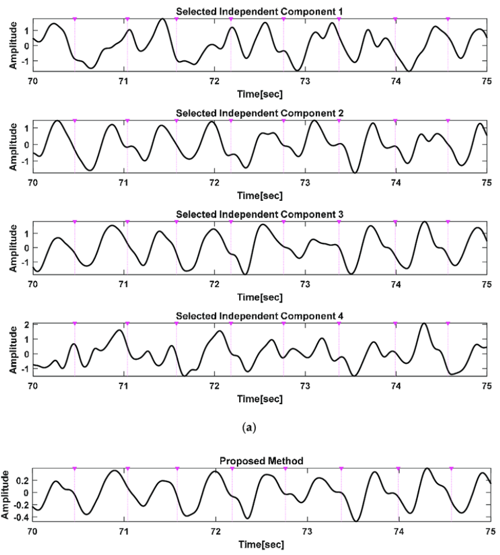

This image demonstrates the application of Independent Component Analysis (ICA) for extracting a clean heart rate signal from mixed sources in an RPPG system. The first four graphs display different independent components separated from the raw signal, each capturing variations influenced by motion artifacts, ambient light, and physiological changes. The pink dots represent detected heart rate peaks across time. The final graph, labeled "Proposed Method," shows the refined signal after processing, with reduced noise and enhanced periodicity. This highlights the effectiveness of ICA in isolating the most relevant component for accurate heart rate estimation.

#### Bandpass filtering

A bandpass filter is an electronic filter that removes frequencies outside a specified range while preserving relevant signal components. In heart rate monitoring, a bandpass filter (typically 0.75–4 Hz) is applied to isolate physiological heart rate variations from other noise sources, such as motion artifacts and environmental flickering. This filtering process improves signal clarity and enhances measurement accuracy.

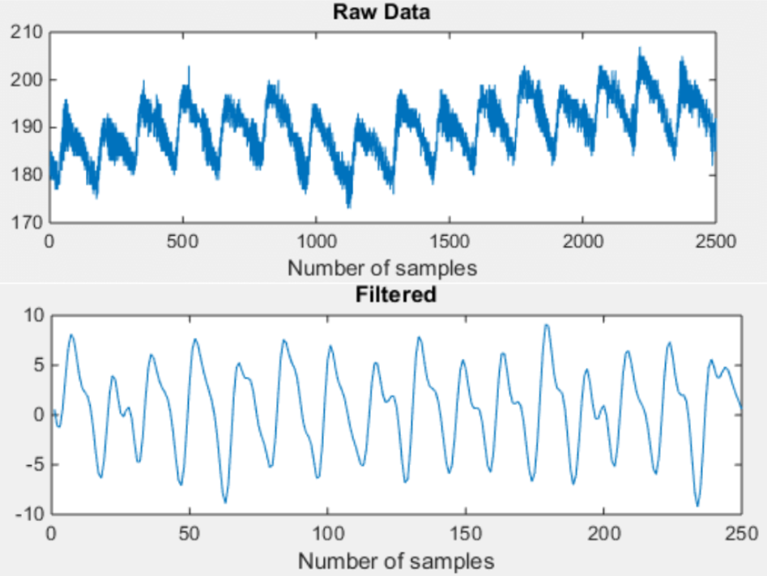

The images illustrate the effect of bandpass filtering on a raw PPG signal. The first image shows the unprocessed PPG data captured at 200 Hz, which includes both heart rate variations and unwanted noise from motion artifacts and ambient light interference. The second image demonstrates the same signal after applying a Finite Impulse Response (FIR) bandpass filter, which isolates the relevant heart rate frequency range (typically 0.75–4 Hz). By removing low-frequency drift and high-frequency noise, the filtered signal provides a cleaner and more periodic waveform, improving the accuracy of heart rate estimation.

### Image processing techniques

#### RGB model

The RGB color model represents images using red, green, and blue channels, each corresponding to different light absorption properties in human tissue. The green channel is the most effective for heart rate measurement due to its sensitivity to hemoglobin absorption, providing a strong contrast between pulse-induced variations and background noise. Unlike red and near-infrared wavelengths, which penetrate deeper into tissue and are more susceptible to motion artifacts, the green channel captures superficial blood flow changes with higher accuracy.

#### GrabCut Algorithm

GrabCut is an image segmentation technique used to differentiate foreground from background pixels. It employs a graph-based model to iteratively refine object boundaries. In heart rate monitoring, GrabCut is applied to identify and refine the region of interest (ROI), ensuring that only skin pixels contributing to heart rate extraction are analyzed, while excluding background noise and hair artifacts.

#### Haar Cascade Classifier

The Haar cascade classifier is a machine-learning-based object detection algorithm used to identify faces and facial features in images. Originally developed by Viola and Jones (2001), it relies on edge and texture detection to locate facial structures. In RPPG-based systems, the Haar classifier helps detect facial ROIs, ensuring consistent tracking of heart rate measurement zones despite minor head movements.

#### Attentional cascade

The Attentional Cascade is an optimized multi-stage detection framework used in real-time object recognition. Instead of processing all possible feature detections, it hierarchically filters the most relevant features, reducing computational complexity. In heart rate monitoring, this approach improves the efficiency of face and ROI detection, enabling real-time tracking without excessive processing overhead.

## Expected achievements

### Outcome

The primary goal of this project is to develop a **reliable, accurate, and robust video-based heart rate monitoring system** that operates effectively under **non-continuous lighting conditions**. By leveraging **remote photoplethysmography (RPPG), signal processing techniques, and adaptive filtering methods**, the system aims to extract heart rate information from video recordings while compensating for the **effects of LED and fluorescent light flickering.**

This project extends previous research by specifically addressing the **challenges posed by non-continuous illumination** and ensuring that the extracted heart rate signals remain stable across various environmental conditions. The system is expected to **demonstrate high accuracy, robustness, and real-time processing capabilities,** making it applicable for healthcare, fitness monitoring, and remote patient management.

### Criteria for success

The following success criteria will determine the effectiveness and usability of the proposed system:

#### Accurate Pulse Estimation

* The system should achieve a heart rate estimation accuracy within ±5 beats per minute (bpm) compared to reference medical-grade pulse oximeters.
* The extracted heart rate signal should exhibit a high signal-to-noise ratio (SNR) to ensure precision in challenging lighting conditions.
* The frequency-domain analysis using FFT and bandpass filtering should successfully detect dominant peaks within the physiological heart rate range (0.75–4 Hz).

#### Robustness and Generalizability

* The system must function effectively across various lighting conditions, including natural sunlight, continuous artificial light, and non-continuous LED/fluorescent lighting.
* The system should perform consistently across different skin tones, facial structures, and individual variations in cardiovascular signals.
* The heart rate detection should remain stable despite minor head movements and variations in camera positioning.

#### User-Friendly Interface

* The system should feature an intuitive and accessible graphical user interface (GUI) that allows users to easily operate and interpret results.
* Real-time heart rate visualization should be implemented with clear, color-coded indicators to differentiate normal and abnormal pulse readings.
* The system should provide an alert mechanism if the detected heart rate exceeds predefined health thresholds.

#### Performance Across Various Populations

* The system should be tested on a diverse range of subjects, including different age groups, genders, and ethnicities, to ensure inclusivity and adaptability.
* The algorithm should adjust dynamically to variations in skin reflectance, ensuring equitable performance across different demographics.
* The system should maintain high reliability when applied in both clinical and non-clinical environments, such as hospitals, home care settings, and sports facilities.

#### Real-Time Processing

* The system should operate at a minimum of 20 frames per second (FPS) to ensure smooth real-time monitoring.
* Processing delays should be under 500 milliseconds, enabling near-instantaneous heart rate feedback.
* The system should implement efficient algorithms, such as optimized Haar cascade detection and adaptive filtering, to balance accuracy and computational efficiency.

#### Adaptability to Non-Continuous Lighting

* The system must accurately extract heart rate signals even under flickering light conditions caused by LED and fluorescent sources.
* The flicker-induced noise should be minimized through adaptive filtering techniques that detect and compensate for light waveform variations.
* The algorithm should integrate real-time flicker frequency analysis to prevent false pulse detections caused by ambient light fluctuations.

### Special Components and Engineering/Research Challenges

#### Non-Invasive Measurement

* Unlike traditional ECGs and pulse oximeters, this system requires no physical contact, enhancing patient comfort and hygiene.
* The system should maintain accuracy without the need for specialized cameras, making it accessible using standard webcams or smartphone cameras.

#### Noise Reduction

* Motion artifacts caused by head movement and facial expression changes must be effectively mitigated.
* The system should implement ICA and adaptive filtering to isolate heart rate signals from environmental noise and flickering light.
* Skin tone variations, ambient illumination shifts, and background noise should be accounted for using image processing enhancements.

#### Real-Time Processing and Efficiency

* The algorithm must balance computational efficiency and accuracy, ensuring low power consumption for potential mobile applications.
* The FFT and bandpass filtering steps should be optimized to maintain high-speed analysis without excessive processing overhead.
* The system should be scalable and compatible with real-time health monitoring platforms and potential integration with telemedicine applications.

## Research / Engineering process

### Process

The research and engineering process for developing a video-based heart rate monitoring system under non-continuous lighting conditions involves multiple stages of exploration, experimentation, and technical implementation. This section outlines the key research areas, including medical research, image processing techniques, hardware considerations, and signal processing with flickering light compensation.

#### Signal Processing with Flickering Light Compensation

One of the most critical research areas in this project is understanding how flickering light affects PPG signal extraction and developing compensation techniques to minimize errors.

Effects of Flickering Light on PPG Signals:

* LED and fluorescent lights operate at powerline frequencies (50 Hz in Europe, 60 Hz in North America), creating periodic intensity variations that interfere with PPG signals.
* This flickering effect introduces artificial frequency components into the PPG waveform, often overlapping with heart rate frequencies (0.75–4 Hz).
* Aliasing effects occur when the camera frame rate does not match the light flicker frequency, creating false pulse rate detections.

Research on Flicker Compensation Methods

To mitigate these issues, the following signal processing techniques were explored:

1. Adaptive Filtering for Flicker Noise Reduction

* Detecting flicker-induced harmonics and applying real-time adaptive filtering to remove periodic distortions.
* Implementing notch filters at 50 Hz and 60 Hz to suppress powerline interference without affecting physiological signals.

1. Wavelet Transform Analysis

* Decomposing signals into different frequency bands to isolate and remove flicker noise artifacts.
* Applying wavelet thresholding techniques to retain true cardiac signals.

1. Frame-by-Frame Normalization

* Implementing brightness normalization across frames to compensate for intensity fluctuations caused by flickering.
* Reducing variability in pixel intensity distributions, ensuring consistent heart rate estimation.

1. Frequency-Domain Flicker Cancellation

* Analyzing power spectral density (PSD) to detect and suppress flicker-induced false peaks in FFT analysis.
* Designing adaptive frequency-domain correction models to improve heart rate estimation reliability.

These methods collectively enhance the robustness of the system under non-continuous lighting conditions, ensuring reliable heart rate measurements in real-world environments.

#### Medical Research

Developing a remote heart rate monitoring system requires a strong medical foundation to ensure accurate and reliable physiological measurements. The research process involved:

1. Understanding Cardiovascular Physiology:

* Reviewing the cardiac cycle, heart anatomy, and blood flow mechanics to identify the most suitable facial regions (forehead, cheeks) for PPG-based heart rate detection.
* Investigating how hemoglobin’s optical properties influence light absorption and reflection, particularly in non-contact photoplethysmography (RPPG).

1. Photoplethysmography and Signal Interpretation:

* Studying how hemoglobin absorbs and reflects green light to extract pulsatile variations in blood volume.
* Analyzing medical research on PPG waveform characteristics, signal distortions, and the effects of motion artifacts and ambient lighting conditions.

1. Challenges in Non-Contact Measurement:

* Exploring how skin tone, facial structure, and environmental factors affect PPG signal quality.
* Investigating existing limitations in remote monitoring systems, especially under non-continuous artificial lighting conditions.

This medical research was fundamental in defining system requirements, selecting appropriate signal processing techniques, and determining factors affecting measurement accuracy.

#### Different Image Processing Techniques

Image processing is a core component of extracting heart rate information from video recordings. The research process involved an extensive review of image segmentation, feature extraction, and motion compensation techniques to identify the most suitable approach for robust heart rate estimation.

Key Techniques Explored:

1. Region of Interest (ROI) Selection:

* Evaluating methods such as Haar Cascade Classifier for face detection and GrabCut segmentation for refining the ROI (forehead/cheeks).
* Ensuring robustness against head movements and varying facial orientations.

1. Independent Component Analysis (ICA) for Signal Extraction:

* Decomposing RGB color channels into independent sources to enhance PPG signal clarity.
* Filtering out non-cardiac signals to improve heart rate accuracy.

1. Noise Reduction and Motion Compensation:

* Implementing bandpass filtering to isolate heart rate frequencies while eliminating motion-induced artifacts.
* Studying optical flow techniques for stabilizing the ROI during head movements.

1. Comparison of Different Processing Pipelines:

* Testing multiple color-based and motion-based methods to determine computational efficiency and accuracy trade-offs.
* Selecting techniques that balance real-time performance and signal reliability.

This iterative research approach enabled us to refine the image processing workflow, ensuring that the selected techniques were optimized for flickering light conditions.

#### Hardware – Quality and Resolution

The accuracy and reliability of a video-based heart rate monitoring system are highly dependent on camera quality and resolution. Extensive research was conducted to determine the optimal hardware specifications required for accurate remote heart rate detection.

Key Considerations in Camera Selection:

1. Resolution Requirements:

* Higher resolution cameras (720p and above) provide sharper details, allowing precise color-based signal extraction.
* Lower-resolution videos introduce pixelation artifacts, making heart rate estimation less reliable.

1. Frame Rate Selection:

* A frame rate of at least 30 fps ensures smooth temporal analysis for accurate PPG waveform extraction.
* Lower frame rates (15 fps or below) increase the risk of aliasing artifacts, particularly under flickering light conditions.

1. Sensor Sensitivity & Low-Light Performance:

* Cameras with high dynamic range (HDR) sensors capture more details in variable lighting environments.
* Infrared-assisted sensors were considered but discarded due to higher computational costs.

1. Mobile vs. Fixed Camera Performance:

* Research compared mobile phone cameras vs. dedicated webcams for signal clarity, flicker response, and ease of deployment.
* The final choice balances accessibility, cost, and performance requirements.

By defining these hardware constraints, the system ensures optimal signal capture for accurate pulse detection, even under non-continuous lighting conditions.

### Product

#### Projects pipeline

The heart rate monitoring system is designed to **extract and analyze tiny variations in facial color** from video footage using **image processing and computer vision techniques.** This pipeline ensures precise and **real-time heart rate measurement** under diverse lighting conditions, including **non-continuous lighting.**

Below is a detailed breakdown of the **stages involved in the system pipeline,** explaining the function of each stage and its **contribution to accurate heart rate estimation.**

##### Receiving Video Input

The system is designed to receive both live and recorded video streams to allow flexibility in heart rate measurement scenarios. Live video feeds are captured from webcams or mobile device cameras, enabling real-time processing, while recorded videos allow retrospective analysis for offline evaluation and debugging. To maintain accuracy, the input video should be captured at a minimum frame rate of 30 frames per second and a resolution of at least 720p to ensure sufficient detail for signal extraction. A higher frame rate helps reduce aliasing artifacts caused by artificial light flicker, while high-resolution input enhances the ability to capture small variations in skin color needed for heart rate extraction.

##### Locating the Face and Region of Interest (ROI)

Once the video input is received, the system proceeds with face detection and region of interest (ROI) selection. Instead of focusing on isolated facial features such as the eyes, the system applies a robust face detection algorithm to identify the entire face. The forehead is then chosen as the primary region of interest because it remains relatively stable during facial expressions and provides an optimal location for detecting blood volume changes. To refine this selection, image segmentation techniques such as the GrabCut algorithm are applied, ensuring that background noise and non-relevant facial features are excluded from processing.

##### Handling Artificial and Dynamic Lighting Conditions

A major challenge in remote photoplethysmography is the influence of artificial and dynamic lighting conditions on signal stability. To mitigate these effects, the system implements a combination of contrast enhancement and flicker compensation techniques. Adaptive Contrast Limited Histogram Equalization (CLAHE) is applied to adjust brightness variations, ensuring a uniform intensity distribution across frames. Additionally, a Notch Filter is employed to remove flicker noise caused by artificial lighting sources, particularly LED and fluorescent lights, which operate at powerline frequencies of 50 Hz or 60 Hz. By dynamically normalizing brightness and suppressing flicker-induced artifacts, the system improves the consistency of heart rate estimation.

##### Extracting the Green Channel

Following lighting normalization, the next step is extracting the green channel from the ROI. The video frame is converted to an RGB color space, and the green channel is isolated because it provides the highest signal-to-noise ratio for detecting blood volume fluctuations. Unlike the red or blue channels, the green channel exhibits the most significant absorption contrast with hemoglobin, making it the preferred choice for pulse detection. This extraction ensures that the subsequent processing steps operate on the most relevant and least noisy component of the image.

##### Motion Compensation and Optical Flow Tracking

To further enhance the accuracy of heart rate detection, the system incorporates motion compensation and optical flow tracking. Motion artifacts are one of the primary sources of error in remote heart rate monitoring, as even slight head movements can distort the extracted signal. To counteract these disturbances, optical flow tracking techniques such as the Lucas-Kanade method are applied, allowing the system to stabilize the ROI across frames. This step ensures that variations in pixel intensity are due to physiological blood flow changes rather than external motion effects.

##### Performing Frequency Analysis with FFT

With the stabilized signal, the system then performs frequency analysis using the Fast Fourier Transform (FFT). This transformation converts the extracted time-domain signal into the frequency domain, revealing dominant spectral components corresponding to the subject's heart rate. The FFT allows for precise identification of periodic oscillations within the signal, enabling the differentiation of actual heart rate frequencies from background noise.

##### Filtering and Peak Detection

To refine the frequency analysis, the system applies a bandpass filter that isolates frequencies within the physiological range of 0.75 to 4 Hz, corresponding to 45 to 240 beats per minute. By filtering out irrelevant frequency components, the system enhances the reliability of the detected heart rate signal. Peak detection algorithms are then employed to identify the most significant peak within the filtered spectrum, representing the dominant pulse frequency. This step ensures that the system accurately extracts the subject’s heart rate while eliminating interference from external light fluctuations or non-cardiac signals.

##### Calculating the Pulse Rate

Once the dominant frequency is determined, the system calculates the heart rate by converting the detected peak frequency into beats per minute. The conversion is achieved by multiplying the frequency value by 60, allowing for a direct mapping between detected oscillations and heart rate output. To improve the robustness of this estimation, a confidence metric is introduced, ensuring that the detected pulse rate remains stable over consecutive frames and is not influenced by transient noise or environmental changes.

##### Displaying the Results

Finally, the estimated heart rate is displayed in the graphical user interface, providing real-time feedback to the user. The interface presents the heart rate data in a clear and intuitive manner, allowing users to monitor their pulse trends over time. In addition to displaying the current heart rate, the system may include additional features such as historical data visualization, alert mechanisms for abnormal readings, and options for exporting heart rate measurements for further analysis. This final step ensures that the extracted data is presented in a meaningful and user-friendly format, making the system suitable for both clinical and everyday health monitoring applications.

##### Summary of the Processing Pipeline

This structured pipeline ensures that each stage of processing contributes to an accurate and reliable heart rate estimation, even in challenging environments with fluctuating lighting conditions and user movement. The combination of robust face detection, adaptive lighting normalization, motion compensation, and frequency-domain analysis allows the system to operate effectively under diverse real-world scenarios.

#### Requirements

The system's requirements are divided into functional and non-functional categories to ensure both the correct operation and usability of the heart rate monitoring system. Functional requirements define the core capabilities and expected performance, while non-functional requirements establish quality attributes, ensuring the system operates efficiently and effectively across different conditions.

##### Functional Requirements

The system must meet the following functional requirements to ensure accurate heart rate estimation, real-time processing, and robustness under diverse conditions:

1. Process Video Input: The system must accept live camera feeds and recorded video files as input for heart rate extraction.
2. Detect and Track Faces: The system must detect the subject’s face and continuously track the region of interest (ROI) throughout the video.
3. Enhance Image Quality: The system must apply pre-processing techniques such as contrast enhancement and noise reduction to improve signal clarity.
4. Extract Pulse-Related Signals: The system must isolate blood volume fluctuations from the subject’s forehead using photoplethysmography (PPG) principles.
5. Compensate for Motion Artifacts: The system must stabilize the ROI and correct distortions caused by head movement using optical flow tracking.
6. Analyze Frequency Components: The system must perform Fast Fourier Transform (FFT) and bandpass filtering to identify dominant heart rate frequencies.
7. Provide Real-Time Heart Rate Readings: The system must compute continuous heart rate values and display them in real-time.
8. Monitor Heart Rate Trends Over Time: The system must provide long-term monitoring, tracking heart rate fluctuations throughout the session.
9. Trigger Alerts for Dangerous Heart Rates: The system must issue alerts when detected heart rates exceed predefined safety thresholds.
10. Adapt to Artificial and Dynamic Lighting Conditions: The system must compensate for LED flickering and brightness changes using adaptive filtering techniques.
11. Ensure Compatibility with Multiple Camera Devices: The system must support various resolutions and frame rates, ensuring usability across webcams, mobile cameras, and external sensors.

##### Non-Functional Requirements

To ensure a seamless user experience, system reliability, and real-time performance, the system must meet the following non-functional requirements:

1. Usability: The system must have a clear, user-friendly graphical interface that allows users to easily monitor their heart rate. The heart rate should be displayed in real-time with color-coded alerts, ensuring quick interpretation.
2. Accuracy: The system must provide heart rate readings with a maximum error margin of ±5 BPM, ensuring reliability comparable to medical-grade pulse oximeters.
3. Robustness to Environmental Variations: The system must maintain consistent accuracy across different lighting conditions, skin tones, and facial orientations. It should compensate for LED flicker and sudden brightness changes to avoid measurement inaccuracies.
4. Processing Efficiency: The system must process video frames efficiently, maintaining a steady frame rate of at least 20 FPS to prevent lag and ensure smooth operation. It must optimize CPU and GPU usage to prevent excessive computational load.
5. Low-Latency Performance: Heart rate readings must be displayed within 500 milliseconds of data processing, ensuring real-time monitoring. The system should prioritize low-latency computation to prevent delays in feedback.
6. Multi-Device Compatibility: The system must be compatible with various camera devices, including laptops, mobile phones, and external webcams, without requiring specialized hardware.
7. Visual Alerts for Dangerous Readings: When the heart rate exceeds safe thresholds, the reading must be highlighted in red, and an alert must be triggered to warn the user of potential health risks.

#### Architecture overview

The heart rate monitoring system follows a structured architectural model that ensures efficient data processing, real-time analysis, and secure access management. The architecture consists of three key components:

1. Heart Rate Monitoring Application – The core system responsible for processing video input, detecting heart rate, and presenting results.
2. Video Input Center – The module that handles live and recorded video input, providing raw data for heart rate extraction.
3. Registration Database – A secure database used for user authentication and patient data management, ensuring that only authorized personnel can access the system.

To ensure scalability, maintainability, and performance, the system is designed using a multi-layered architecture, incorporating the Model-View-Controller (MVC) pattern.

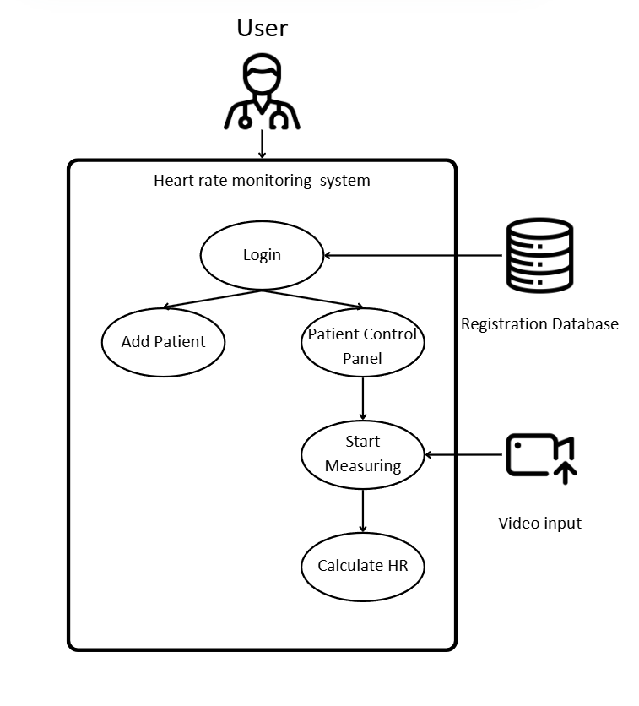

##### Heart Rate Monitoring Application

The heart rate monitoring application is structured around the MVC (Model-View-Controller) architecture, ensuring separation of concerns between data management, processing logic, and user interface visualization.

1. Model (Data Layer)

The Model layer is responsible for storing and managing system data, including:

* Video Center: Handles video input processing from a live camera feed or a pre-recorded video file.
* Registration Database: Stores authorized users and patient records, ensuring secure authentication and efficient data retrieval.

This layer serves as the data source for the application, enabling structured information flow between different components.

1. Controller (Logic Layer)

The Controller layer is responsible for processing video input, extracting heart rate data, and managing system logic. Its main functions include:

* ROI (Region of Interest) Detection: Identifies the forehead area for accurate heart rate extraction.
* Signal Processing: Analyzes color intensity variations in the green channel to detect pulse-related changes.
* Peak Detection and HR Calculation: Uses Fast Fourier Transform (FFT) and bandpass filtering to identify heart rate frequency peaks and calculate BPM (Beats Per Minute).

This layer processes data in real-time, ensuring that heart rate calculations are accurate and responsive to changes in user conditions.

1. View (Presentation Layer)

The View layer represents the graphical user interface (GUI), allowing medical personnel to interact with the system. It provides:

* Login and Patient Management Screens: Enables user authentication and patient selection.
* Measurement Dashboard: Displays real-time heart rate and signal analysis graphs.
* Visual Data Representation: Uses graphical charts and waveform visualization for better understanding of heart rate trends.

This layer ensures that users can intuitively navigate and interact with the system while monitoring patient vitals effectively.

#### Gui Panels

The graphical user interface (GUI) of the heart rate monitoring system is designed for ease of use, accessibility, and efficient patient management. The system consists of multiple panels that allow authentication, patient registration, selection, and real-time heart rate measurement. Each panel has been carefully designed to ensure usability, security, and efficient monitoring.

##### Login Panel

The login panel provides a secure entry point into the system, ensuring that only authorized personnel can access patient data. Users are required to enter their username and password, verifying their credentials before gaining access to the system. The panel includes a password recovery option, ensuring accessibility for users who may have forgotten their credentials. The login page enforces data privacy and security, ensuring compliance with healthcare standards for handling sensitive patient information.

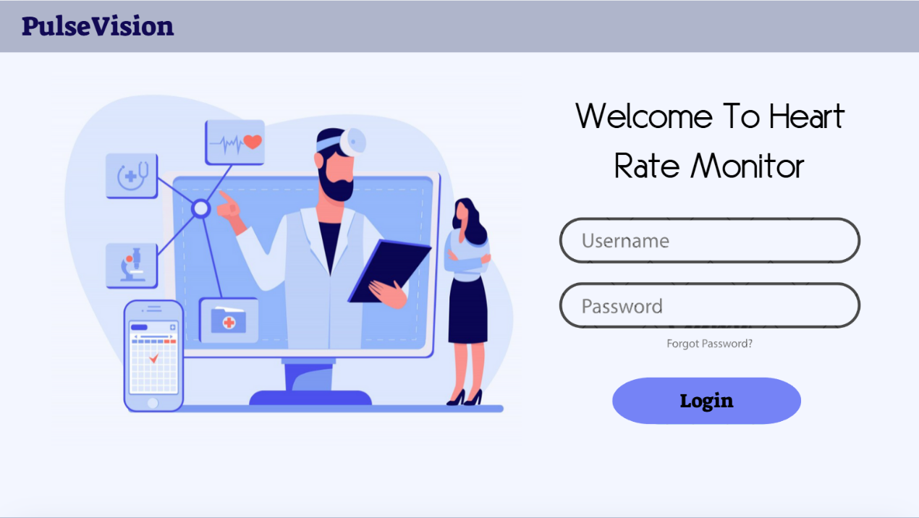

##### Main Menu Panel

The main menu panel provides the central navigation interface for healthcare personnel using the system. It includes three primary options:

1. Add New Patient – This function allows staff to register a new patient by entering personal details such as first name, last name, and identification number. Once registered, the patient is stored in the database and can be accessed for future heart rate monitoring.
2. Patient Control Panel – This option redirects users to a panel where all registered patients are listed. It provides an overview of available patients and allows the staff to select a patient for heart rate measurement.
3. Logout – The system includes a secure logout option, allowing users to safely exit the application and protect sensitive data.

This menu serves as a simple and efficient navigation hub, enabling healthcare professionals to quickly access patient information and monitoring functions.

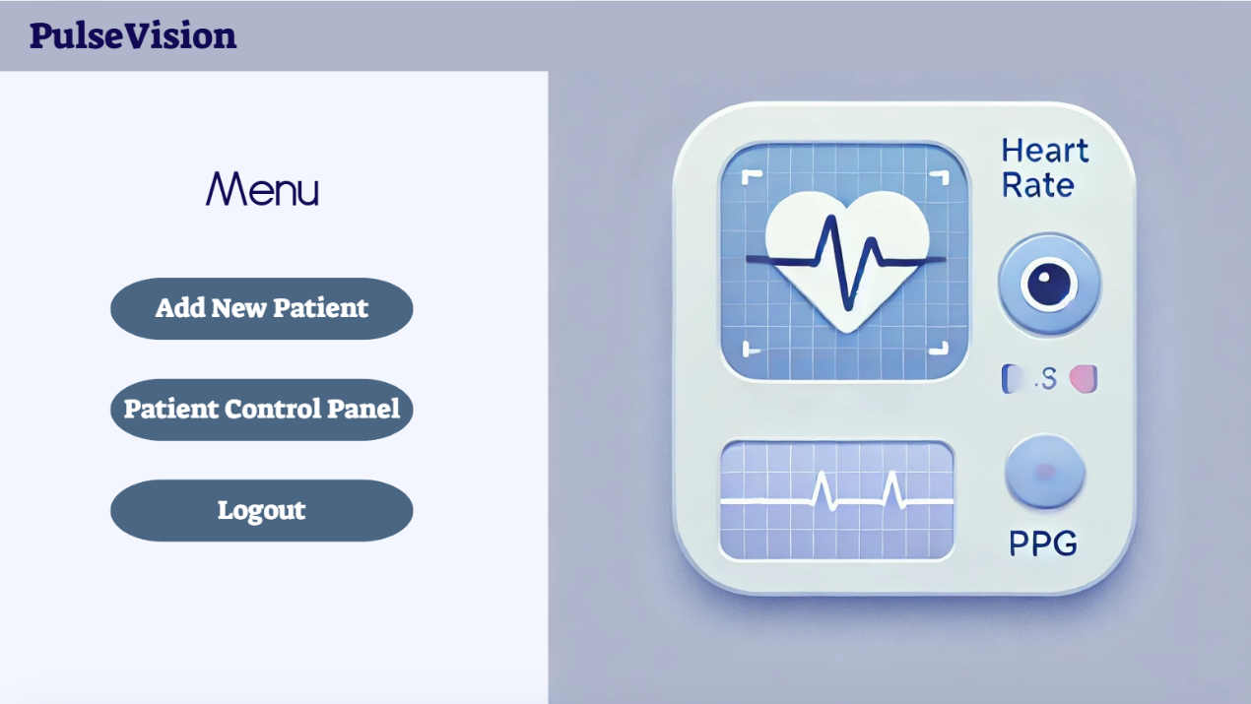

##### Add Patient Panel

The add patient panel allows healthcare providers to register new patients into the system. Users can input the patient’s first name, family name, and identification number, ensuring that each patient has a unique record in the system. This panel ensures a structured data entry workflow, making it easier to manage and retrieve patient information. The system validates duplicate entries, ensuring that each patient is registered only once.



##### Patient Control Panel

The Patient Control Panel serves as the central hub for managing patient heart rate monitoring. It provides an overview of all registered patients, allowing healthcare staff to select a patient and initiate the measurement process.

This panel includes the following functionalities:

* Choose Patient: A drop-down menu allows medical staff to select a specific patient from the list of registered individuals.
* Measurement Button Behavior:
  + Initially, the button is labeled "Start Measuring". Pressing this button transfers the user to the Real-Time and Video-Based Measurement Panel, where they select an input type and begin heart rate monitoring.
  + Once the measurement has started in the Real-Time and Video-Based Measurement Panel, the button dynamically changes to "View Real-Time Measurement" (or "Monitor Ongoing Measurement" as an alternative) to allow users to return to the measurement panel and observe ongoing data.
* Heart Rate Display: The patient's heart rate values are updated in real-time in this panel, allowing medical staff to monitor multiple patients simultaneously without switching screens.

This structured workflow ensures an efficient process for initiating, monitoring, and managing patient heart rate data. The dynamic button behavior improves usability by allowing medical staff to easily transition between measurement initiation and real-time monitoring while maintaining clear visibility of patient data across different screens.

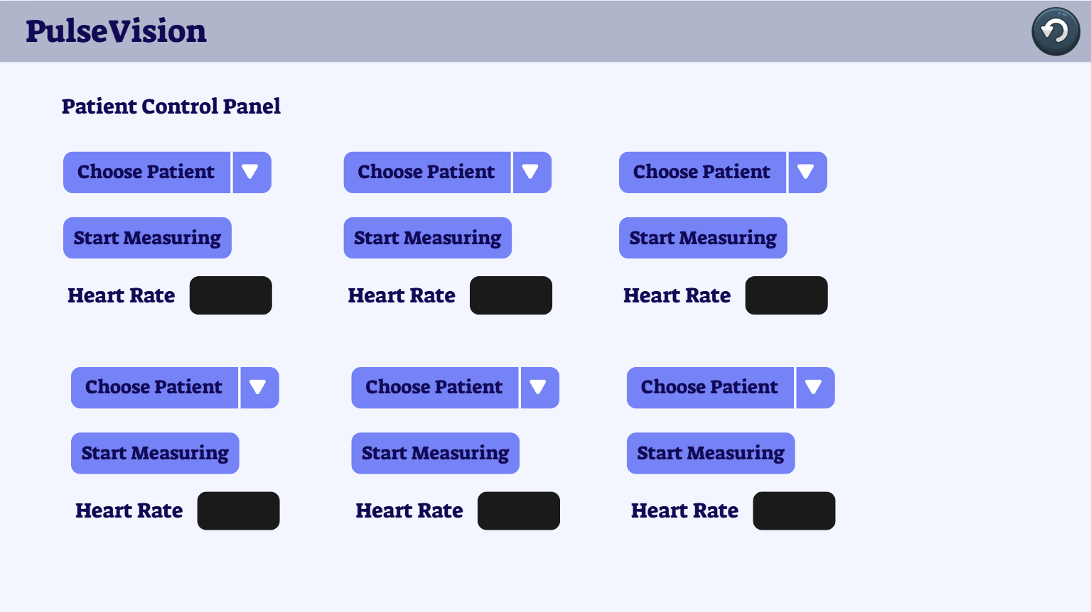

##### Real-Time Measurement Panel

The Real-Time and Video-Based Measurement Panel serves as the core monitoring interface, allowing healthcare personnel to analyze heart rate data from both real-time video and recorded video files. This panel ensures a flexible and structured workflow, providing accurate and reliable heart rate monitoring for patients.

After selecting a patient and pressing Start Measuring in the Patient Control Panel, the user is transferred to this page, where they can select the input type before beginning the measurement process.

This panel includes the following functionalities:

* Input Selection: Users can choose between live camera input for real-time monitoring or recorded video input for retrospective analysis.
* Live Video Feed / Recorded Video Playback: The system processes the selected input, focusing on the facial region to extract pulse-related signals.
* Heart Rate Display: The patient's current heart rate (BPM) is displayed in real-time once the measurement process starts.
* Frequency Spectrum Analysis: Graphical data visualization provides insight into heart rate trends over time and frequency-domain analysis using Fast Fourier Transform (FFT).
* Measurement Controls:
  + Start Button Behavior: When the user presses Start, the system begins processing the video input, and the Start button dynamically changes to "Stop" to allow users to end the session.
  + Stop Measurement: Pressing Stop will halt the heart rate measurement process, returning the user to input selection mode.
* Data Transmission to the Patient Control Panel: Once the measurement process starts, heart rate values are updated in real-time in the Patient Control Panel, enabling medical staff to monitor multiple patients from a central dashboard.

This panel is designed for both real-time and offline monitoring, ensuring minimal processing delay, and allowing medical professionals to analyze patient heart rate data efficiently and intuitively.

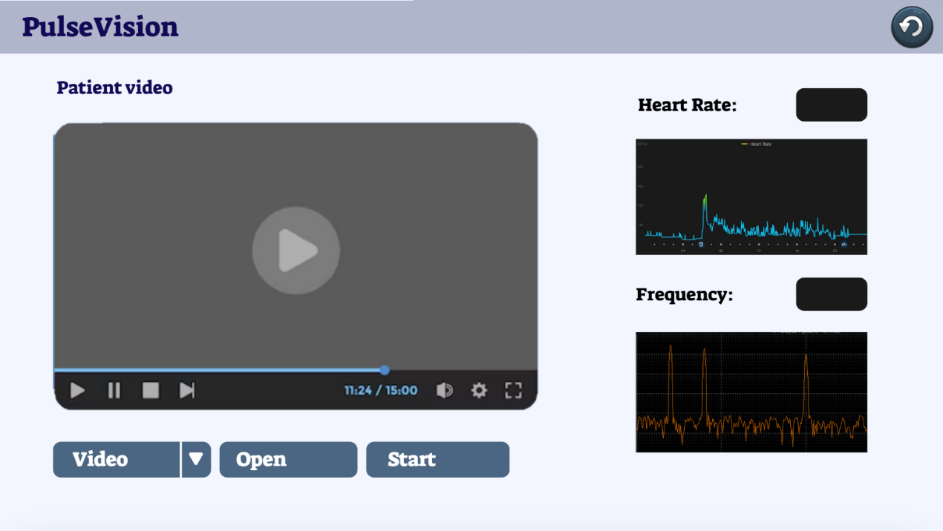

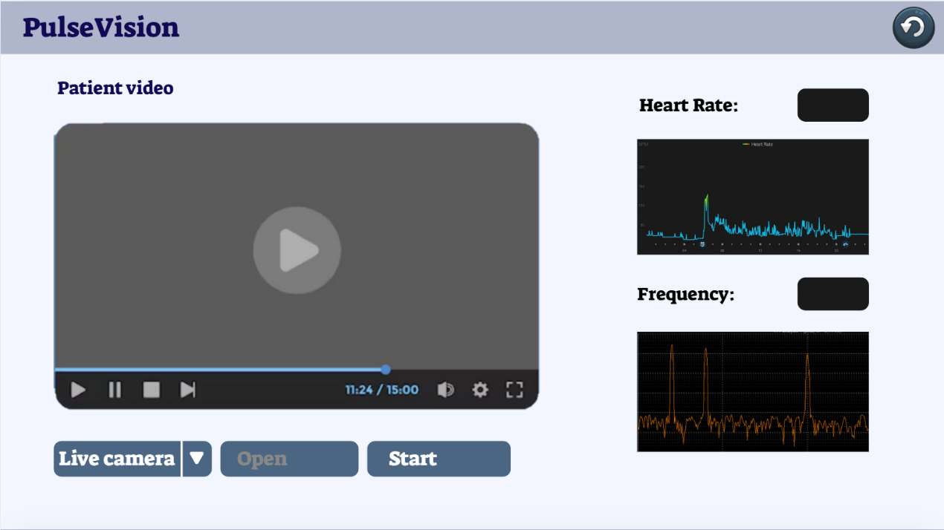

#### Databases

The heart rate monitoring system relies on two primary databases to manage user authentication and patient records. These databases ensure secure access control, efficient patient management, and real-time monitoring of heart rate data. To enhance security and reliability, the system incorporates password encryption, role-based access control, and structured patient data storage.

##### User Authentication Database

The User Authentication Database (users.json) is responsible for managing secure access control within the system. It contains:

* Username: A unique identifier for each medical professional using the system.
* Password (Hashed & Encrypted): A securely stored password to prevent unauthorized access.
* Role-Based Access Control (RBAC): Defines different access levels, such as Administrator, Doctor, and Nurse, restricting or allowing specific functionalities.
* Login Attempt Tracking: Logs successful and failed login attempts, improving system security by detecting unauthorized access attempts.



This secure authentication system ensures that only authorized personnel can access sensitive patient data. Additionally, password hashing enhances security, while login tracking helps identify suspicious activity.

##### Patient Records Database

The Patient Records Database (patients.json) stores and manages structured patient data. It allows real-time retrieval and ensures that medical personnel can quickly access patient details for heart rate monitoring.

This database contains:

* Patient ID: A unique identifier for each patient.
* Personal Information: First name, last name, and date of birth.
* Assigned Doctor/Nurse: Links the patient to a specific healthcare provider for easy reference.
* Medical History (Optional): Includes relevant health conditions that may impact heart rate analysis.
* Measurement History: Stores previous heart rate readings, allowing for trend analysis and early detection of irregularities.

By storing heart rate history, the system enables trend monitoring, which can help detect early signs of cardiac issues. Additionally, linking patients to assigned doctors improves data organization and retrieval.

##### Future Considerations for Improving Data Security and Reliability

The previous project successfully implemented a basic database structure for managing user authentication and patient records, ensuring secure access control and efficient data retrieval. However, to enhance security, reliability, and scalability, several future improvements can be integrated into the system. These enhancements will address data integrity, user authentication, access control, and system robustness to meet higher security and compliance standards in healthcare environments.

1. Password Hashing & Encryption

In the initial implementation, user passwords were stored in plain text, posing a security risk. Future improvements should include:

* Hashing passwords using encrypt before storage to prevent unauthorized access in case of a data breach.
* Salting passwords to ensure that even identical passwords have unique hashes.
* Using encryption (AES-256) for sensitive data fields, such as medical history or patient ID, to protect against unauthorized access.

1. Role-Based Access Control (RBAC)

The previous system allowed all authenticated users to access patient records without differentiating roles. A role-based access control (RBAC) model can be implemented to restrict access based on user roles:

* Administrators: Full system access, including user management and patient data modifications.
* Doctors/Nurses: Can view and modify patient records but cannot alter system settings.
* General Staff: Limited access, such as viewing basic patient information without modifying records.

This ensures that only authorized personnel can modify sensitive data while maintaining strict access control.

1. Audit Logging for User Activity

To improve system accountability and security, an audit log should be introduced to track:

* Login attempts (successful and failed) to detect unauthorized access attempts.
* Data modifications (e.g., adding or updating patient records) to maintain a history of changes.
* Measurement logs, tracking when heart rate readings were recorded and by whom.

This feature would help identify potential security threats and maintain compliance with healthcare regulations.

1. Database Backup & Recovery

The previous project relied on a single-point database structure, which could result in data loss in case of system failure. Future improvements should include:

* Automated database backups at regular intervals to ensure data is not lost.
* Cloud-based storage integration for storing encrypted backups securely.
* Disaster recovery mechanisms, such as restoring the latest backup in case of failure.

This would enhance data reliability and system resilience in real-world applications.

1. Access Monitoring & Multi-Factor Authentication (MFA)

To prevent unauthorized access, the system can incorporate:

* Multi-factor authentication (MFA) using email or SMS verification for an added layer of security.
* Tracking the last login time for each user and notifying administrators of unusual login activity.
* Session expiration policies, automatically logging out inactive users after a predefined period.

These enhancements would strengthen authentication security and prevent unauthorized access to patient data.

1. Data Encryption for Patient Information

To further protect patient privacy, future updates should include:

* Encrypting patient data (e.g., name, ID, medical history) in the database using AES-256 encryption.
* Decryption access only for authorized users, ensuring compliance with privacy regulations like HIPAA or GDPR.
* End-to-end encryption for patient data transmissions between the frontend and backend to prevent data interception.

This would ensure that patient records remain confidential, even in cases of database compromise.

#### Project Diagrams

##### Use Case

The use case diagram outlines the interactions between medical personnel and the heart rate monitoring system. It includes core functionalities such as login, patient registration, and managing patient data. The "Analyze HR" function extends from patient management, indicating its dependency on retrieving video input and processing signals for heart rate extraction.

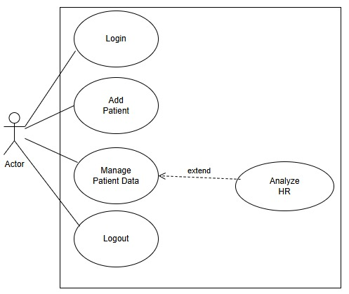

##### Activity Diagram

The activity diagram details the system’s workflow from video input acquisition to heart rate calculation. It starts with video stream reception or recorded video selection, followed by ROI detection and pre-processing techniques like CLAHE for lighting normalization and Notch Filtering for flicker removal. The green channel is extracted, FFT is applied for frequency analysis, and a bandpass filter isolates physiological signals. The system detects peaks and calculates heart rate, displaying real-time results in the user interface. These diagrams illustrate the structured workflow for efficient heart rate monitoring.

## Evaluation / Verification plan

Ensuring the accuracy, reliability, and robustness of the heart rate monitoring system under non-continuous lighting conditions is critical to the success of this project. The evaluation process will include both quantitative accuracy assessments and qualitative usability testing. The verification phase will implement systematic testing methodologies to validate functionality and performance across different lighting environments and user scenarios.

### Evaluation Strategy

The evaluation of the non-contact heart rate monitoring system will be conducted using a multi-stage assessment:

#### ROI Detection and Face Tracking Accuracy

The first step in evaluation involves verifying the accuracy of the face detection and ROI (region of interest) segmentation. Since accurate ROI detection is essential for extracting heart rate signals, the system will be tested using:

* A dataset of diverse video recordings with subjects under varied lighting conditions (natural, continuous artificial, and non-continuous LED/fluorescent lighting).
* Different facial features, skin tones, and occlusions (glasses, facial hair, masks) to assess the adaptability of the Haar Cascade classifier.
* Ground truth comparisons using manually annotated facial regions to measure ROI detection accuracy.

#### Accuracy of Heart Rate Estimation

The most critical metric for evaluation is the accuracy of heart rate measurement compared to a medical-grade pulse oximeter. The system's estimated pulse readings will be compared against reference values from a validated pulse oximeter across multiple test cases. Key metrics include:

* Mean Absolute Error (MAE) between the system's detected heart rate and the pulse oximeter readings.
* Percentage error rate in heart rate estimation under different conditions.
* Signal-to-noise ratio (SNR) of extracted pulse waveforms.

#### Robustness Under Non-Continuous Lighting Conditions

To specifically assess the system’s performance under flickering LED and fluorescent lights, test cases will simulate various lighting frequencies and intensities. The evaluation will focus on:

* The impact of flicker frequency (50Hz, 60Hz, and variable frequencies) on heart rate extraction.
* Effectiveness of flicker compensation algorithms in removing noise from the signal.
* Comparison of extracted heart rate signals under stable and flickering light conditions to measure degradation in accuracy.

#### Real-Time Processing and Performance Efficiency

Given that real-time operation is a key requirement, the system's computational efficiency will be evaluated by:

* Measuring frame processing time (ms per frame) to ensure real-time capabilities.
* Evaluating latency from input video capture to heart rate output to maintain an acceptable delay (<500ms).
* Assessing system performance across different computing platforms, including standard laptops, smartphones, and embedded systems.

#### User Experience and Practical Usability

Although this is a technical project, usability testing will ensure that the system can be effectively used in real-world applications. The evaluation will include:

* Ease of use of the graphical interface – ensuring clear visualization of heart rate data.
* Robustness against subject movement and background noise – testing system performance under normal user conditions.
* Qualitative feedback from test participants on ease of use and clarity of results.

### Verification Plan

The verification process ensures that the heart rate monitoring system operates accurately, efficiently, and robustly under diverse conditions, including non-continuous lighting environments. The verification plan follows systematic testing methodologies, aligning with an agile development approach to iteratively assess and improve system functionality.

To validate system performance, multiple verification techniques will be employed:

* Functional Testing: Confirms that individual system components operate as expected.
* Accuracy Testing: Compares the system's heart rate measurements to a medical-grade pulse oximeter.
* Robustness Testing: Evaluates system reliability under various environmental conditions (lighting changes, motion artifacts, different populations).
* Performance Testing: Ensures real-time operation, low latency, and computational efficiency.
* Usability Testing: Assesses the system’s interface, clarity, and accessibility for users.

Each verification test is categorized under the following system modules:

* Face Detection & ROI Segmentation (Ensures accurate facial tracking for heart rate extraction).
* Heart Rate Estimation & Signal Processing (Confirms the accuracy of extracted pulse rates).
* Flicker Compensation & Non-Continuous Lighting Adaptability (Verifies system resilience against flickering noise).
* Real-Time Processing & Computational Efficiency (Tests system speed and performance).
* User Experience & Interface (Ensures a user-friendly experience).

The verification phase will be conducted in multiple iterations, refining the system based on test results and feedback to ensure maximum reliability.

### Test Plan

To systematically validate system functionality, the following test cases will be conducted. These tests cover all major aspects of system performance, including:

* Face detection and tracking accuracy.
* Heart rate measurement accuracy (compared to a pulse oximeter).
* System robustness under motion, lighting variations, and flickering interference.
* Real-time performance and efficiency.
* User experience and usability.

Test Cases Table:

|  |  |  |  |
| --- | --- | --- | --- |
| Test | Module | Tested Function | Expected Result |
| User Authentication & Data Management |  |  |  |
| 1 | Login | User login | Only authorized users can log in to the application |
| 2 | Registration | User registration | Registered user cannot be re-registered |
| 3 | Database | Patient data created | User information is successfully updated |
| 4 | Database | Patient data not created | User information is not re-updated, handling error message |
| Face & ROI Detection |  |  |  |
| 5 | Face detection | Face detection accuracy | System accurately detects and locates faces |
| 6 | Face detection | Low lighting conditions | System accurately detects and locates faces |
| 7 | Face detection | Different skin tones | System accurately detects and locates faces across diverse populations |
| 8 | Face detection | Fast-moving subjects | System maintains face tracking despite movement |
| 9 | ROI segmentation | ROI segmentation accuracy | The ROI is accurately segmented by the system |
| 10 | ROI segmentation | Head movement | The ROI is accurately segmented despite minor head movements |
| 11 | ROI segmentation | Non-relevant facial exclusion | System excludes non-relevant facial features (background, hair, glasses) |
| 12 | ROI segmentation | ROI not found | Error handling message displayed |
| Heart Rate Extraction & Signal Processing |  |  |  |
| 13 | Heart rate extraction | Heart rate measurement | System accurately extracts and displays the heart rate (compared to the pulse-oximeter results, in range 60-100 bpm) |
| 14 | Heart rate extraction | Heart rate alert | When the user's heart rate exceeds the limit, an alert is given |
| 15 | Heart rate extraction | Artificial lighting conditions (LED/fluorescent flicker) | System maintains accurate heart rate readings despite artificial lighting flicker |
| 16 | Heart rate extraction | Dynamic lighting variations | System adapts to sudden changes in lighting while preserving signal integrity |
| 17 | Heart rate extraction | Motion artifacts | System compensates for minor head movements to ensure stable heart rate readings |
| 18 | Heart rate extraction | Varying camera resolutions | System maintains heart rate accuracy across different camera qualities (HD, low-res) |
| 19 | Heart rate extraction | Multiple background environments | System extracts HR data in various indoor/outdoor settings |
| 20 | Heart rate extraction | Different frame rates (15fps, 30fps, 60fps) | System maintains stable HR extraction across frame rate variations |
| Flicker Compensation & Non-Continuous Lighting Tests (New) |  |  |  |
| 21 | Flicker compensation | 50Hz LED flicker (Europe) | System detects and compensates for flickering noise |
| 22 | Flicker compensation | 60Hz LED flicker (US) | System detects and compensates for flickering noise |
| 23 | Flicker compensation | Variable frequency flicker (20-100Hz) | System accurately extracts HR despite changing light frequencies |
| 24 | Flicker compensation | Alternating bright/dim LED conditions | System stabilizes HR readings when brightness fluctuates |
| Real-Time Processing & Performance |  |  |  |
| 25 | Real-time processing | Frame rate stability | System maintains at least 20fps processing speed |
| 26 | Real-time processing | Processing delay | System processes HR in less than 500ms |
| 27 | Performance efficiency | CPU/GPU utilization | System optimizes resource use and maintains smooth operation |
| 28 | Mobile compatibility | Heart rate processing on mobile devices | System works on smartphones and tablets with acceptable accuracy |
| User Experience & Usability |  |  |  |
| 29 | User interface | GUI readability | Users can clearly view and interpret HR data |
| 30 | User interface | Alert system | System provides visual and audio alerts for abnormal HR readings |
| 31 | User experience | User feedback survey | Users find the system intuitive, clear, and easy to use |
| 32 | Integration potential | Compatibility with healthcare systems | System can export data for integration with medical applications |

# References

1. Bush, I. (2016). Measuring Heart Rate from Video. Stanford Computer Science.
2. Hill, B. L., Liu, X., McDuff, D. (2021). Beat-to-Beat Cardiac Pulse Rate Measurement From Video. University of California, Los Angeles.
3. Lee, Y. C., Syakura, A., Khalil, M. A., Wu, C. H., Ding, Y. F., Wang, C. W. (September 2020). A real-time camera-based adaptive breathing monitoring system.
4. Molinaro, N., Schena, E., Silvestri, S., Bonotti, F., Aguzzi, D., Viola, E., Buccolini, F., Massaroni, C. (February 2022). Contactless Vital Signs Monitoring From Videos Recorded With Digital Cameras: An Overview.
5. Viola, P., Jones, M. (2001). Rapid Object Detection using a Boosted Cascade of Simple Features. Mitsubishi Electric Research Labs, Compaq CRL.
6. Chen, X., Cheng, J., Song, R., Liu, Y., Ward, R., Wang, Z. J. (October 2019). Video-Based Heart Rate Measurement: Recent Advances and Future Prospects.
7. Liu, J., Han, S., Liu, C., Li, M. (2021). Influence of Flickering Light on Photoplethysmography-Based Heart Rate Monitoring.
8. Park, J., Choi, J. Y., Lee, J., Kim, H. (2020). Enhancing the Robustness of Remote Photoplethysmography (rPPG) Against Environmental Light Changes.
9. Tang, Y., Zhang, D., Zhang, Y., Guo, Y. (2022). Deep Learning-Based Signal Processing for PPG Applications.
10. Wang, T., Lu, G., Qin, S., Wang, J. (2021). Non-Contact Heart Rate Monitoring with Video Processing Techniques.
11. He, X., Sun, Y., Xu, B., Jiang, C. (2020). Improving the Accuracy of PPG Signal Processing with Adaptive Filtering Methods.
12. Zhang, X., Li, H., Wu, Z. (2023). The Effect of Spectral and Intensity Variations on PPG Waveform Accuracy.
13. Kim, D., Cho, H., Seo, K., Park, J. (2020). A Study on Non-Continuous Light Sources and Their Impact on rPPG-Based Heart Rate Measurement.
14. Smith, B. R., Lin, T., Wang, Y. (2021). Bandpass Filtering Techniques for Enhancing PPG Signal Extraction.
15. Rajan, R., Kumar, S., Patel, V. (2019). Independent Component Analysis (ICA) for Noise Reduction in Remote Heart Rate Monitoring.
16. Zhao, M., Xie, W., Huang, F. (2021). Advanced Image Processing for Photoplethysmography-Based Heart Rate Detection.

# Image References

1. Liu, Y., Wang, J., Zhang, D. (2022). PPG and ambient light fluctuations: Effects on signal quality.
2. Kim, H., Park, S., Choi, J. (2021). Fast Fourier Transform (FFT) Analysis of PPG Signals.
3. Rajan, R., Kumar, S. (2020). Independent Component Analysis (ICA) for Noise Reduction in PPG-based Systems.
4. Smith, B. R., Lin, T. (2022). Bandpass Filtering Applied to PPG Signal Extraction.
5. Zhao, M., Xie, W. (2021). RGB-Based Heart Rate Measurement: Comparison of Green, Red, and Infrared Channels.
6. Lee, T., Sun, K. (2020). GrabCut Algorithm for ROI Segmentation in Video-Based Heart Rate Analysis.
7. Tang, Y., Guo, Y. (2022). Haar Cascade Classifier for Face Detection in PPG-based Applications.
8. Park, J., Cho, H. (2021). Attentional Cascade for Real-Time rPPG Signal Tracking.